**[day of week] | [date range] | [time]**

**Location:  
Cost including materials: $ for members, $ general public**

**RSVP to [name] at [number] or [email]**

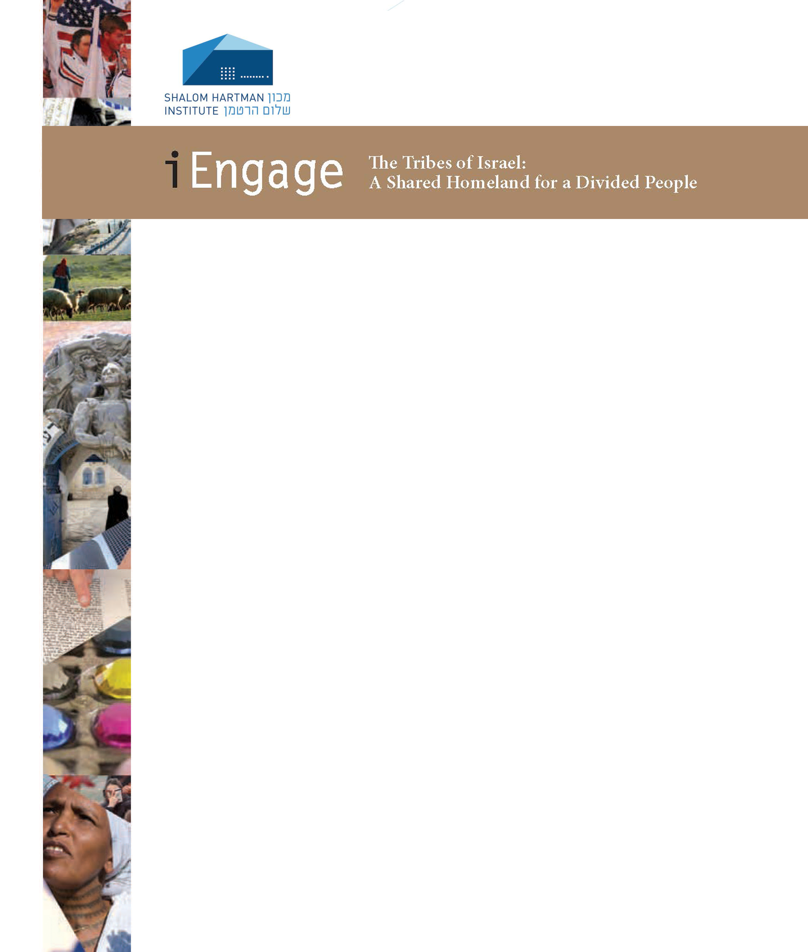

**iEngage: The Tribes of Israel *A Shalom Hartman Institute Lecture and Study Series***  
**Led by Rabbi [name]**

Through video lectures and interviews, text study, and lively group discussion, we are pleased to bring the world-renowned faculty of the Shalom Hartman Institute   
into the [name of synagogue] community this fall.

**What is the significance of the State of Israel as a Jewish public sphere?**

The focus of this series is to confront the challenge of creating a Jewish and democratic public space in the modern State of Israel – a shared common space for a people divided along tribal affiliations: religious, ideological, national, and geographic. The Tribes of Israel begins a conversation to restructure the relationship between the collective and the individual “tribes” that comprise it – a relationship where tribal affiliations, convictions, and rights are balanced against collective consciousness and identity.

**Each session includes** text study and discussion led by Rabbi [name], and video lectures and interviews with leading Hartman scholars.