_

***A Shalom Hartman Institute Lecture and Study Series*Led by Rabbi [Name]**

Through video lectures, text study, and lively group discussion, we are pleased to bring the world-renowned faculty of the Shalom Hartman Institute into the [name of synagogue] community this fall.

**iEngage: Jewish Values and the Israeli-Palestinian Conflict** explores one of the most divisive issues affecting the Jewish peopletoday: the Israeli-Palestinian conflict. Through the study of Jewishnarratives about Israel and the unpacking of the complex meanings ofpeace in Jewish tradition, participants are invited to explore the ideasand values that animate different attitudes toward the conflict and how these values shape their own political understandings. Though a shared political platform may not be attainable, this course strives to achieve a shared respect for our differences.

Together we will engage in a new values-based discourse about Israel, including topics such as: Living with Difference, the Israel We Imagine, Jewish Narratives of Peace, Attitudes Towards the Land, Justice, Self-Preservation, Compromise, and the Idea of Jewish Exceptionalism.

**Each session includes** text study and discussion led by Rabbi [name], and video lecture and interviews with leading Hartman scholars.

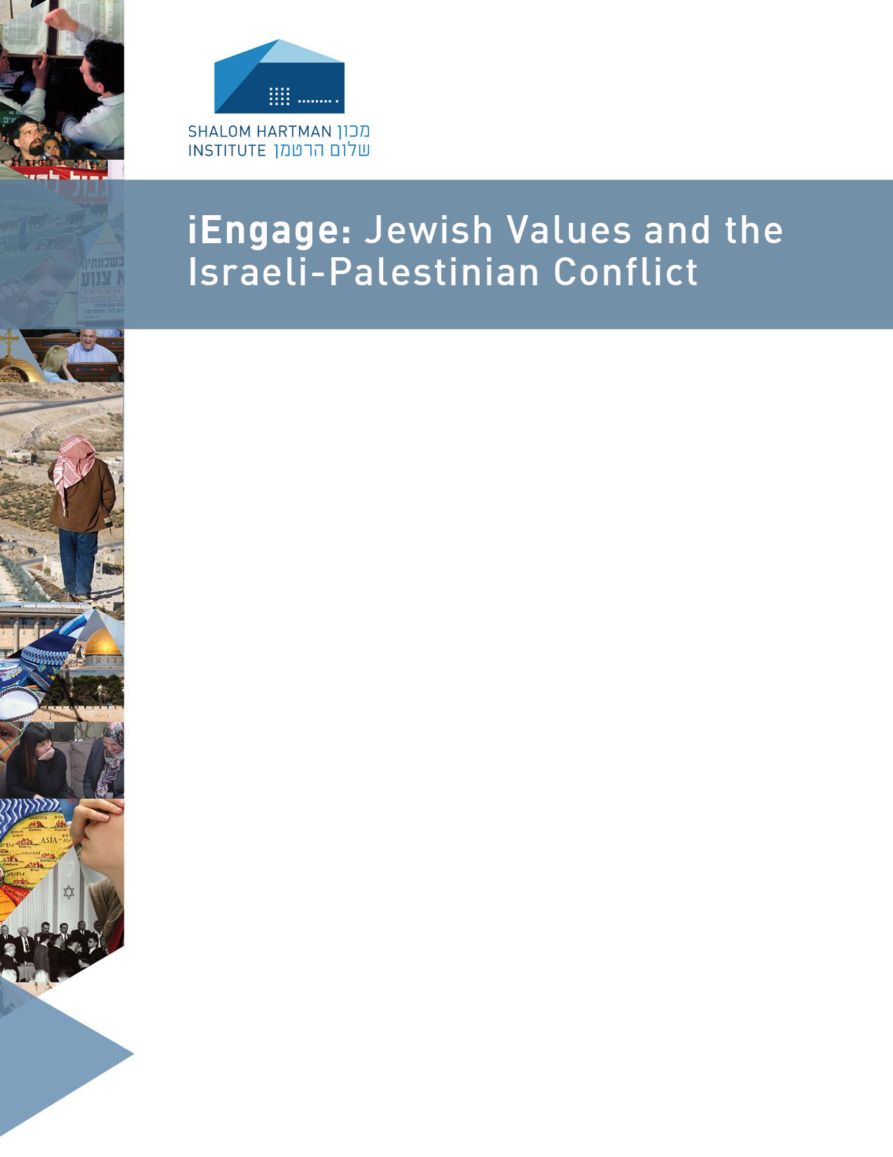

**iEngage: Jewish Values and the Israeli-Palestinian** **Conflict**

**[day of week] | [date range] | [time]**

**Location:   
Cost including materials: $ for members, $ general public**

**RSVP to [name] at [number] or [email]**